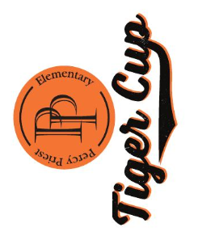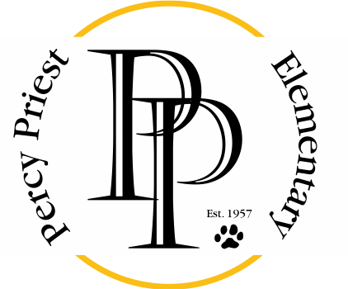
August 16, 2018

Dear Community Supporter,

Percy Priest Elementary School’s Parent Teacher Association (PTO) is gearing up for its annual Tiger Cup Golf Tournament fundraiser, and we need your help! Set for September 24, 2018, our event is expected to have over 120 guests in attendance. We would love your partnership in supporting our children and educators by having your business represented at our fundraiser, and would be grateful if you would consider becoming a sponsor and/or donating to our event. All donations are tax deductible and we would be happy to provide the school’s tax ID number if requested.

While Metro Nashville Public Schools provides funding for the basics of education, our school relies heavily on fundraising supplement services and supplies for professional development, salaries for Interventionist teachers, an Enrichment teacher and workroom assistants. It also funds Technology and much needed supplies for our Music, Art, Spanish, and Physical Education Programs.

Not only will you be helping to provide a better education to the children in our community, the families of 495 Percy Priest Elementary School students will be exposed to your business. To show your generosity, your business will appear in our weekly e-blasts leading up to the Tiger Cup, on a banner in front of the school, hole signs at the tournament and more, listing you as one of our school supporters. Details regarding sponsorship are on the following page.

Thank you for your consideration and continued support! Because of our community partners, Percy Priest Elementary School is ranked among the top 5% of public elementary schools in Tennessee. Please feel free to contact us with any questions. We look forward to following up with you.

Sincerely,
Kass and Aaron Benchoff
Percy Priest Tiger Cup Committee
www.percypriest.org/tigercup
kassbenchoff@yahoo.com
TIGER CUP SPONSORSHIP OPPORTUNITIES

The Cup Sponsor - $5,000
- Premier advertisement on all promotional materials and signs at school
- Exclusive sponsor of the driving range and putting area
- Two teams for the Golf tournament
- Name on the Sponsorship banner at PPE
- Main sponsor on all school email blasts with link to your company’s website

The Masters Sponsor - $2,500
- Company logo on banner at event.
- Exclusive sponsorship with logo on sign of one of the contests
- One team for the golf Tournament
- Name on the Sponsorship banner at PPE

The Open Sponsor - $1,000
- Hole sponsor with logo or name on sign.
- One team for the golf tournament
- Name on Sponsorship banner at PPE

The Tiger/Hole Sponsor - $250
- Hole Sponsor with company logo or individual’s name on sign

