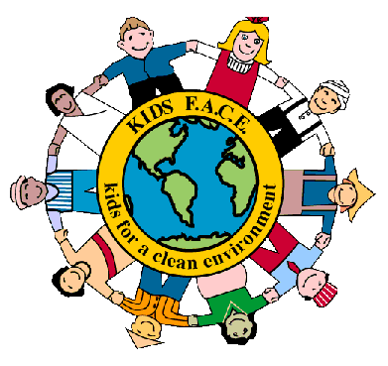

Percy Priest’s Kids For A Clean Environment

WHAT: Join us this year for Percy Priest’s earth club, Kids for a Clean Environment (Kids FACE). We will meet the first Tuesday of every month along with bonus activities throughout the year. Activities will be focused on outdoor fun and building leadership skills. Our activities will include planting in the Percy Priest gardens, making recycled paper, creating a rain garden, creek exploration, hiking at Radnor Lake, and much more! The club is free to join and welcomes K-4th grade. Our first meeting will take place Tuesday, September 4th.

WHEN: First Tuesday of Every Month
3:00-4:15pm

WHERE: We will meet in Mrs. Acker’s 1st Grade Classroom

CONTACT: Melissa Hood
615-589-5884
moepoehood@gmail.com

###

