Welcome to 2nd grade Music from Mr. Mott!
Hello 2020-2021 2nd grade Music Students!

If you have not yet made your Quavermusic student account please do so ASAP. Until you do this YOU WILL NOT BE ABLE TO SEE the things I put in your account under the Assignment tab. Follow these steps below to set up your Quaver student account:

FOR STUDENTS to set up their quavermusic student account:
I want you to do this through CLEVER - DO NOT DO THIS THROUGH quavermusic.com:)

Step #1: Go to https://clever.com/in/mnps and sign in. 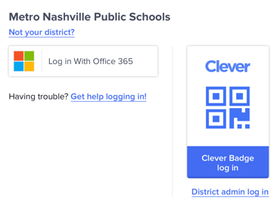

Step #2: Go to the Quaver Music App.

Step #3: NEXT, notice in the lower right corner a field for a CODE [J64WD] this puts you into my 2nd grade class so you can see 2nd grade assignments.

Step #4: Once you've done this you should be taken to your very own student dashboard page!

Step #5: Explore and play around. Please do not spend money on QuaverNotes. I have codes for free notes to send to you.

Step #6: Click on the ASSIGNMENT tab and you'll see what I have put in for you, some of your favorite songs. (coming soon)

If you have any questions send me a message. james.mott@mnps.org or IG @Tigermusic215

Mr. Mott

