Welcome to Kindergarten 2020-21!

Dear Parents,

Welcome to Percy Priest Elementary! We hope this short guide will give you helpful information about the year ahead for your kindergartener at PPE. There is a tremendous amount of information available at the school’s website that is pertinent to ALL students. Visit us at www.percypriest.org for even more details.

This year is starting very differently than usual. We know that you likely have TONS of questions. We are here for you. Please do not hesitate to reach out at any time. For now, we wanted to provide you with some information about the school so when we do return, you will have some idea what to expect.

This will be a year packed with fun and quite a bit of change for your kids, and we welcome your questions and feedback. We would also love to have you volunteer at the school in small or large ways. Come together to join us!

Kass Benchoff & Ginny Dolezal
PPE PTO Co-Presidents
presidentsPPE@gmail.com

Lingo

Friday Folders
Folders are sent home each Friday, filled with your child’s work from the week and announcements about happenings around PPE. They are to be returned empty each Monday. Be sure to check your child’s folder after school on Friday because occasionally teachers send home time-sensitive info.

INVEST
This is the PTO’s primary fundraising effort. PPE parents are encouraged to contribute $350 per student. This funding is vital to pay the salaries for four interventionists and enrichment teachers who support our teachers and students. These positions make a tremendous impact on so many of our students and their learning. The Invest campaign also pays for the new laptops our students will use during virtual school and when they return to the building, as well as supporting the needs of our related arts teachers (art, Spanish, music and PE). If you have questions about INVEST, please contact INVEST chairs, Nicole Provonchee and Lindsey Murrell, InvestPPE@gmail.com.

Orange Totes
All kindergarteners use the same orange totes in lieu of backpacks. They can be monogrammed but are otherwise uniform. Details about monogramming will be sent separately should you chose to do so. The PTO funds these totes and will plan to distribute them prior to school starting (in person). They may also be picked up at the front office once school resumes in person.

School Clubs
Teachers from each grade offer their students various after school club opportunities. Fees apply and topics vary. Details and registration forms will be sent home in Friday folders. Information will also be available on the PPE website in August.

Snacks
Kindergarteners have afternoon snacks each day. Please pack a dry, peanut-free snack each day and send it in your child’s tote.

Standard School Attire (SSA)
PPE follows Metro School District’s policy pertaining to standard school attire. More information is available on the website for our school’s specific requirements at http://www.percypriest.org/students/standard-school-attire. PPE “spirit wear” will be available for purchase at the Tiger Store throughout the year. All dresses and skirts must be worn with shorts or leggings (which do not need to be solid or specific colors). Spirit wear shirts may be worn any day of the week. Spirit athletic short/skorts may only be worn on Friday’s.

Supply List
For virtual learning, MNPS will be providing the supplies for all students in the district. Their goal is to have these sent to the schools the week of August 10th. If you would like to purchase your own items in advance, the teachers have recommended the following items for all grades:
- Composition notebook(s)
- Small dry erase board/markers
- Folder(s)
- Crayons
- Pencils/Erasers
- Glue Sticks
- Scissors
If you have purchased items through First Day School Supplies, they will be shipped to the school the week of July 27th. There will be the opportunity to pick up your kits and/or supplies from the district. Details for item pick up will be sent out in the coming weeks. Thank you for your patience.

For a complete list of school supplies, stay tuned. We will have that posted shortly.

Transportation
All children arrive and depart from school as either walkers, car riders, or bus riders. Car riders can get their numbers during the popsicle party or orientation. Bus assignments will be mailed. The PPE website has information on transportation here: http://www.percypriest.org/students/back-to-school-guide.

On the first day we return for in-person learning, many PPE parents choose to walk their children to the classroom. Parking is encouraged on Priest Road and Willshire Drive, and it gets crowded! Kindergarten teachers allow parents to walk their students to the classrooms for a short period thereafter, but then request that students get comfortable finding their own way.

During the first week of in-person school, all methods of transportation tend to be slower than normal. Teachers and staff as well as 4th Grade Ambassadors will be available to help kindergartners. PTO volunteers are assigned to help parents navigate the traffic circle. Please be patient and follow the safety rules - NO cell phone use during arrival and dismissal per Tennessee State Law and the safety of our children.

Car Rider Protocol - Drop Off
Drop off begins at 7:40am, and students can use this extra time to enjoy breakfast in the Cafe, or head directly to their classrooms. Breakfast is free to all students. The front doors close at 8:00am, so students are encouraged to arrive between 7:40 - 7:55am. After 8:00 am, parents will be required to walk children in, and sign them in at the front desk.

In order to prepare your child to exit your car, please have them ready with tote in hand, and goodbyes finished, once you cross the first Tiger Paw. Remember - parents, grandparents and babysitters, please do NOT exit your car during drop off.

Car Rider Protocol - Pick-Up
Dismissal begins promptly at 3:00pm. Parents, grandparents, and babysitters are encouraged to begin lining up before 3:00pm along Otter Creek and Priest Road.

Round One Dismissal - The first group of cars lined up in the semi-circle will resemble the graphic included in this document, including buses in the third row.

Rounds Two, Three, and Four Dismissal - The first round of cars and the buses leave the semi-circle, and Mrs. Cathy or another school representative will wave your car in when it’s your turn. Cars will be lined up in three rows between the Tiger Paws. Once you are in your spot, please put your car in park and wait for students to be dismissed to your car. You will be able to exit your car at this point to let your child know where you are in line. Teachers will dismiss children to cars by turning a STOP sign to GO or SLOW.

Car Rider Numbers
Please work with your child to learn his or her Car Rider Number before school starts, or even consider writing it on their tote bag/tag. Car Rider Numbers will be distributed prior to in-person school for new families. Returning families will continue to use the same number. Details about obtaining a car rider number will be sent closer to return to in-person learning.

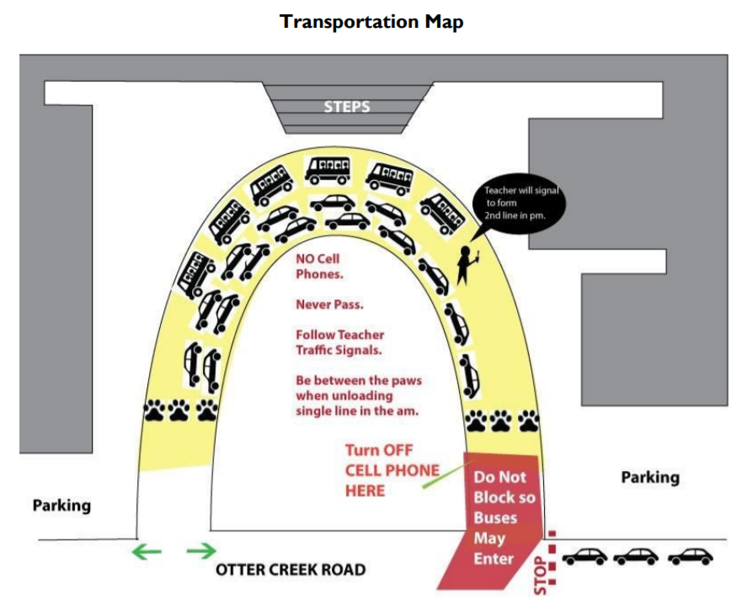
*Please note, during Round One of Dismissals, only two rows of cars are allowed in the semi-circle. This is to provide buses the room they require to line up in the third row. The second row of cars MAY NOT line up past the second speed bump near the mailbox. This only applies to Round One of Dismissals - after buses depart, cars may line up between the Tiger Paws, 3 rows deep.
Events

Before (in-person) School Begins

Kindergarten Readiness Camp
Get a preview of what a kindergarten day AT SCHOOL will be like with two PPE kindergarten teachers, Ms. Benson and Mrs. Condra. Children will be immersed in readiness activities through children’s literature, songs and games. Kids will tour the school, playground and kindergarten classrooms. Dates are to be determined closer to resuming in-person school.

Orientation “Sneak-a-Peek” and Popsicle Party – This event is postponed at this time.

Class Parties
Each class will have various seasonal parties, such as Harvest, Winter/Gingerbread House making, and Valentines. Details to follow.

Fall Events

Open House – This even will be virtual.
All parents are highly encouraged to attend VIRTUAL Open House, an evening when teachers build community with and among parents by going over information specific to their classes, introducing room parents and compiling contact information to create class email distribution lists. Please see the PTO calendar for Open House times.

Family Picnic – Date TBD
All PPE families are invited to have dinner courtesy of Nashville food trucks and enjoy live music, face painting, games, and more. Details will follow.

Tiger Cup Fundraiser
The PTO hosts an annual Golf Tournament fundraiser. This year it will be held on September 21, 2020, at Old Natchez Country Club. Details can be found on the school website. Round up a golf group and join the fun while raising money for the school!

Walk to School Day
Buses still run on Walk to School Day, but all students are encouraged to walk the last part of their journey to school if they are interested. Parents can park on neighboring streets (except where marked) and walk with their kids to the school.

Field Trips – Subject to change due to Metro’s policies in the 2020-21 school year
Kindergarteners go 2-3 field trips per year. Parent volunteers will be needed to serve as chaperones. Your child’s teacher and/or room parent will provide more information on these events.

50’s Day
The kindergarten classes celebrate the 50th day of school by dressing up in 50’s costumes. Attire suggestions will be provided.

Harvest Celebration
Fall festival-type activities are hosted in the kindergarten classrooms, with the help of parents. More details to follow.

Scholastic Book Fair
Each Fall, the library hosts an annual, week-long book fair which includes several fun events, including Grandparents and Special Friends Lunch, when loved ones are invited to join children for lunch (expect a crowd!). Please see the PTO calendar for dates and times.

Gingerbread Houses
Each classroom will have its own gingerbread house making party shortly before winter break. It is strongly suggested that one parent or guardian attend, as construction requires assistance!

Spring Events

100th Day of School
The kindergarten classes celebrate the 100th day of school by dressing up as their 100 year old selves. Attire suggestions will be provided.

Used Book Sale
Donate old books that are in good shape for other families to purchase and enjoy. Parents will send money to school with their kids to buy the books.

Valentine’s Day Party
Each classroom will have its own Valentine’s Day party. Details will follow, with opportunities for parents to assist.

Read-A-Thon
Read-A-Thon is a Metro Schools initiative that lasts for 10 days each spring. It is filled with fun activities and of course, reading!

Spring Auction
The Spring Auction is our 2nd biggest fundraiser of the year. The date is TBD but typically held at Richland Country Club. There will be an Online Auction prior to the event, and both a Silent and Live Auction the night of the event. Camps, restaurant and store gift cards, art, décor, spa certificates, and so much more will be available for purchase or bid. Popular items include grade level baskets, teacher outings, class parties, no SSA (Standard School Attire) for a day or a week, and Sock Wars! More information to come. Plan to attend!

Field Day
Fun activities are available for all grades in the school. Parents are encouraged to volunteer. It serves as the end-of-the-year celebration.

Dine Out With PPE
Throughout the school year, we partner with local restaurants. Enjoy dinner with family and friends, and 20% of sales is donated to PPE. Check the calendar on the PTO website and look for flyers in your child’s Friday folder.

School Lunches
When we resume in-person school, Kindergarten Lunch is from 11:35 am - 12:05 pm. Students are welcome to purchase lunch in the Café or bring lunch from home.
*Updated to reflect the 2020-21 school year by MNPS Prices for school lunches (subject to change):
● Breakfast: No cost for all students
● Elementary & MS Student Lunch: $2.50 daily
● High School Student Lunch: $2.75 daily
● Adult Lunch (MNPS Employees and Volunteers): $3.50
● Adult (Non-MNPS Employees and non-volunteers): $3.75
● Non-enrolled Pre-K children and visiting MNPS students: Breakfast is based on a la carte pricing. Lunch is $2.75
● A visiting MNPS student is one that is eating at a school other than where they are enrolled and they are not there on official school business, i.e. eating lunch with their sibling.

For school menus - http://mnpsnutritionservices.org/index.php?page=menus .
Information and application for free and reduced lunch - https://www.mnps.org/cep/.
For more information about adding funds to your child’s account for lunch, please see the Student-Parent Handbook. We use at app called Meal Viewer to load funds to your child’s account. You are also to pay via cash or check at the front office as well.
How to Get Involved

Birthdays / Lunches at School
Parents have always been welcome to come have lunch with their children in the Café; however, this is subject to change. Stay tuned for details regarding MNPS visitation policies. Kindergarteners eat promptly at 11:35. Parents may purchase a lunch from the Café or bring their own food. Parents may bring lunch for their kids, as well.

PTO
Get involved in the PTO! This is a great way to support your children and make friends along the way. There are many opportunities throughout the year to volunteer. Please don’t hesitate to reach out to the PTO Board or Committee Chairs. We would love to hear from you! https://www.percypriest.org/parents/pto-leadership/.

Visiting the School
During school hours, all visitors must enter through the main doors. Ring the buzzer on the left side, and you will be asked to identify yourself and reason for visiting, and then you may proceed to the office to receive a name badge, which must be worn at all times while in the building.

