Kindergarten Tote Bag Monogramming
Would you like your child’s name or initials on their PPE tote?*
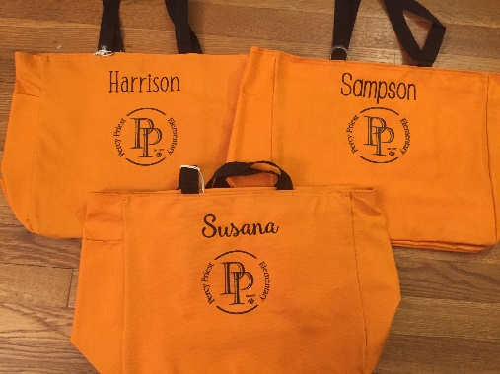
Please text or email Jennifer Perry with the following information by Monday, August 10th
so that your bag will be available at PPE for pickup on Friday, August 14th at school. Details re: pick up will come in future communications.

Child’s name Font style Teacher
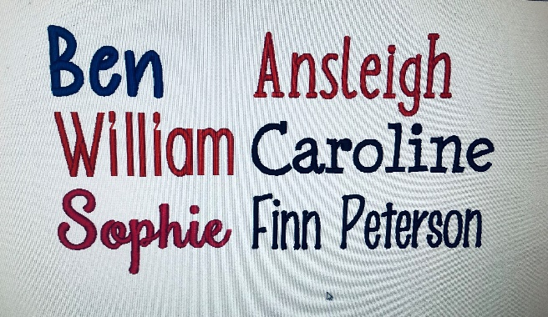
Example: I’m ordering a bag for Joe Schaedle. I want it to say “Joe” in the Ben font. He’s in Mrs. Patterson’s class.

Thread color will be black unless your child has another preference. Other options are: Hot pink, royal blue, purple or white which all show up nicely on the bag.

Cost $15
Venmo @Jennifer-Perry-31
Paypal jennifertalbert@bellsouth.net
If you need to pay with cash or check just let me know.

Please email or text me with your orders directly.
Jennifer Perry
615.482.2432
jennifertalbert@bellsouth.net

*This is completely optional. All bags will be available for pick up on 8/14/2020 at PPE.

