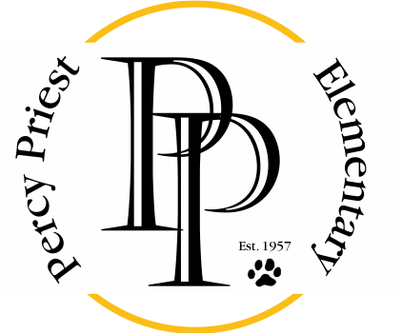

August 3, 2020

Dear Parents,
Welcome to the 2020 - 2021 school year! This year, we have the honor of co-chairing the PTO’s INVEST Committee, which raises critical dollars to support PPE’s students, teachers, and families directly. We both have children at Percy Priest and have experienced the meaningful and productive work the teachers and the staff provide our children.
This year is unlike any other school year, and your gift are very important. The INVEST campaign provides interventionalist teachers, supplies, technology, and money for the important programs and curriculum the teachers implement so masterfully each year.
We would be very grateful if you would contribute to the INVEST campaign this year.
Each year, the Percy Priest Elementary PTO raises money to fund six interventionists and workroom assistants, supplies, appreciation events, technology, library books, teacher education scholarships, and much more. The PTO decides where the funding will be directed, based on advice from teachers and direct feedback from parents. These funds fill the gaps between what the school system can provide and what teachers consider to be core needs. INVEST ensures that our teachers have what they need to do what they do best.
The largest fundraising event of the year is the INVEST campaign, and with so many unknowns about hosting events and other fundraisers during this school year, INVEST is even more important!
This year, the PTO is asking each family to consider a gift of at least $350, or more per child to reach our goal of $140,000 for the 2020-2021 INVEST campaign. We understand that every parent’s financial situation is different, so any amount you can donate is appreciated.
Giving to the INVEST campaign this year will be quick and easy. In just a few weeks, you will receive more information and link where you can make a gift or a pledge to support PPE and INVEST.

Thank you for considering supporting our nurturing and academically minded school. We hope that you will support the INVEST campaign with us.

Sincerely,

Nicole Provonchee and Lindsey Murrell

