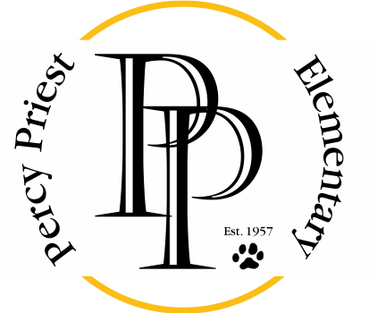

August 3, 2020
Dear Percy Priest Families,
Welcome to the 2020-2021 school year! At Percy Priest we are always focused on providing a safe and nurturing educational environment that will supply all students with the foundation they need to fulfill their highest academic potential and become lifelong learners. We want our graduates to be well-rounded, compassionate, critical thinkers and active members of the local and global communities in which they live.

The teachers and staff are excited and looking forward to a great year of learning, growth, and community building with your children. Our partnership with our families in the educational experience of students is always important, but as we begin the year virtually, this connection will be essential to a successful school year. As we work to navigate this new territory together, please know that you can reach out at any time with questions or if you are in need of support.

We welcome your participation and support this year and solicit your involvement in the Percy Priest Elementary Parent Teacher Organization (PTO). Working together, we will be able to reach our goals and celebrate the achievements of our students.
We hope to see you on Monday, August 3rd at 6 pm for a Teacher Meet and Greet as well as later this month on Tuesday, August 25th at our (virtual) Open House. You will receive important information from us and your child’s teacher regarding grade level expectations for the 2020-2021 school year.
Your partners in education,
Dr. Russell Young, Principal
Brooke Temple, Assistant Principal

