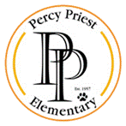2023-2024
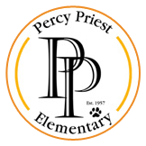Percy Priest Elementary
2nd Grade Supply List

Personal Supplies (Please label with name)
- Scissors
- Plastic Pencil Box (5.6 in x 8.4 x 2.5 in)
- Headphones
- Reusable Water Bottle (if desired) with Flip Top Lid

Classroom Community Supplies (Do not label with name)
- 1 Black Wide Ruled Composition Book
- 1 Red Spiral Notebook
- 2 Boxes of 24 Count Crayons
- 1 Box of Thick Point Markers
- 1 Box of Thin Point Markers
- 1 Box of Colored Pencils
- 1 Box of Pre-Sharpened Pencils
- 8 Fine Point Dry Erase Markers
- 1 Box Pencil Cap Erasers
- 3 Plastic Folders WITH Pockets (1 red, 1 green, 1 blue)
- 3 Packages of Disinfectant Wipes
- 2 Boxes of Facial Tissues
- 1 Box of Bandages

Wish List

- Disinfecting All-Purpose Cleaning Spray
- Paper Towel Rolls
- Cardstock (white and/or color)
- Colored Printer/Copy Paper
- Multi-Color Construction Paper
- Zip Top Plastic Bags (any size)
- Flair Pens
- 8 Broad Point Dry Erase Markers
- Large Paperclips

Thank you!! The Second Grade Team is looking forward to a GREAT year!

