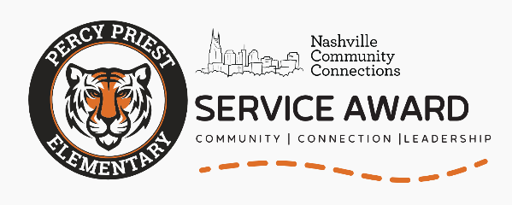
Program Prompt: This award is inspired by UniCycle, a program that started right here at Percy Priest Elementary with one basket and a simple idea to help students who needed school uniforms. Now it helps kids all over Nashville. Your idea could be next.
The winning project will receive a $500 budget and planning support from the Nashville Community Connections team.
📝 Student Application Form
Student Name: ___________________________________________
Teacher: __________________________________________________
Please answer the following questions on a separate sheet(s) of paper. Staple it to this cover sheet and turn in to your homeroom teacher by Friday, May 15.
1. What is your idea, and what positive change will it create?

2. How will you make this happen? List a few categories of actions to take, or steps in order. Include permissions/partnerships needed, and how the project will reach its intended audience.

3. Why do you want to do this project? Do you have a particular source of inspiration or have you seen this need in person? Is it something you learned about after asking questions?

4. How will your project keep making a difference over time? Can it be replicated or can it grow? It might fill a one-time need, and that’s okay!

📅 Timeline
- Application Due: Friday, May 15
- Service Project “Business Plan” Due: August 1
- Check-Ins: Before Fall Break + periodic meetings throughout the school year, as necessary
- Final Review: End-of-year reflection and planning for next year, if applicable

